**ASSIGNMENT 7.1**

**Problem Statement**

We have a dataset of sales of different TV sets across different locations. Records look like: Samsung|Optima|14|Madhya Pradesh|132401|14200 The fields are arranged like:

Company Name|Product Name|Size in inches|State|Pin Code|Price Sales_TV:

**Sales of different TV Task 4 :** Write a Mapreduce program to modify Sales of different TV Task 2 ( refer session 5 assignment 2 ) to use a custom partitioner with 4 reducers. Make sure that all records whose company name starts with A-F (upper or lower case) should go to 1st reducer, those starting with G-L to 2nd reducer, those starting with M-R to 3rd reducer and others to 4th reducer.

**DRIVER**

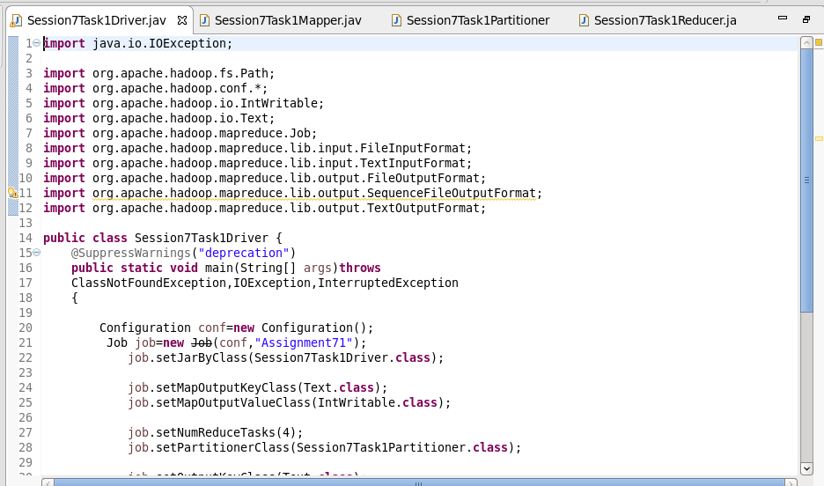

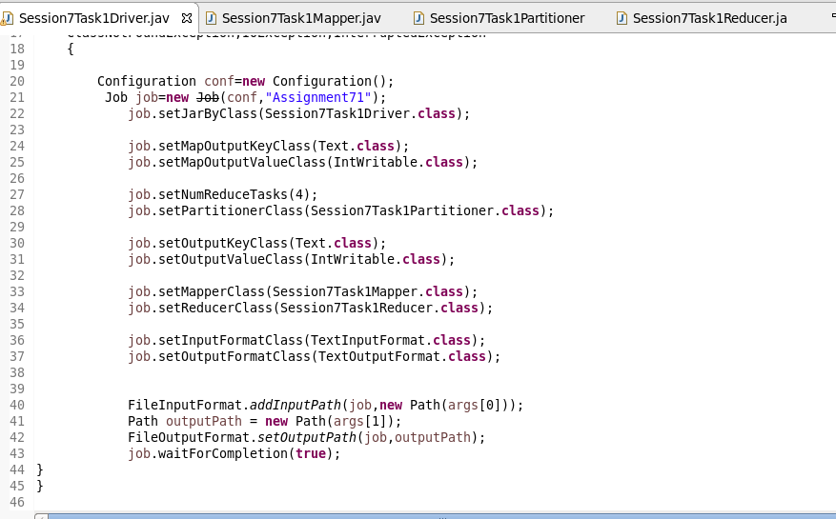

**MAPPER**

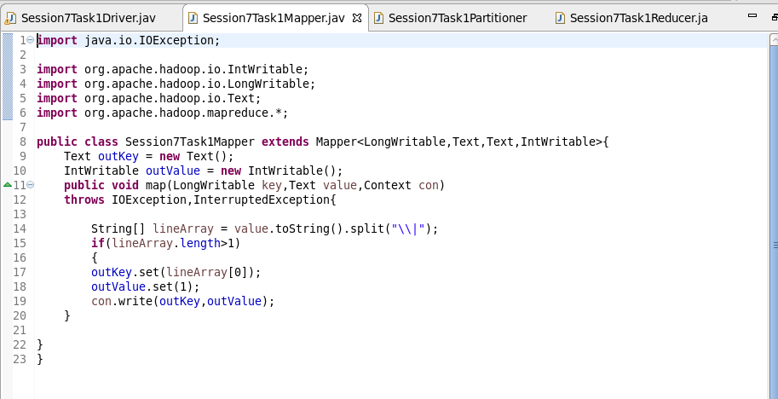

**PARTITION**

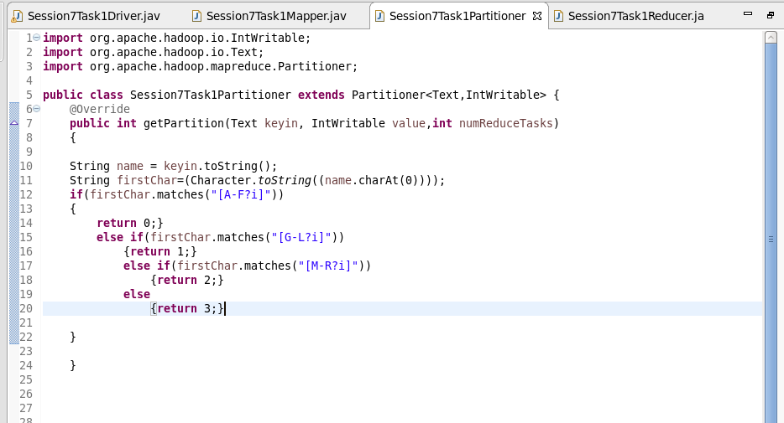

**REDUCER**

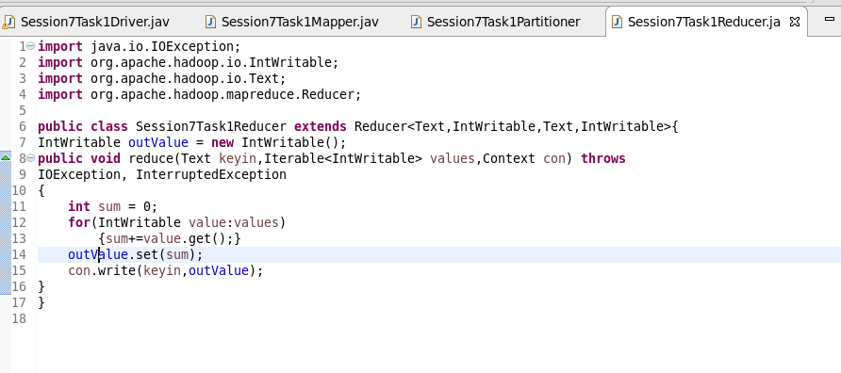

**RUNNING JAR**

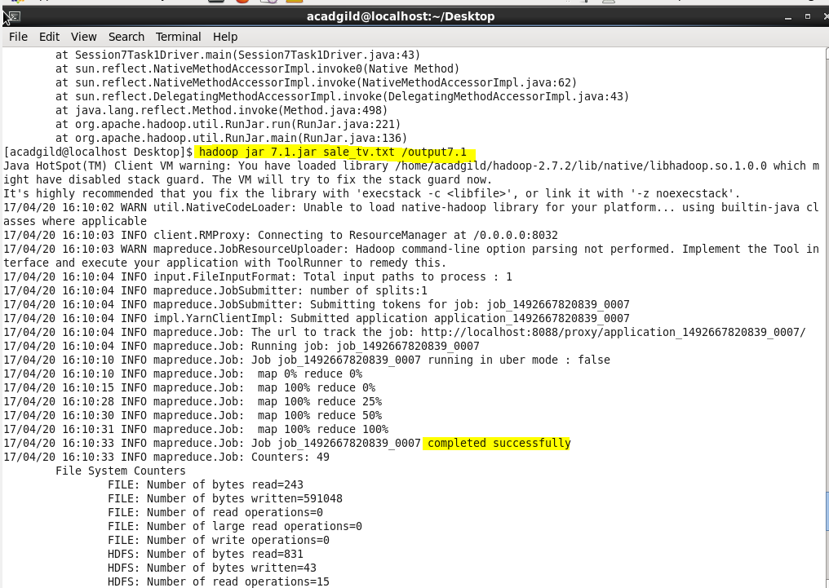

**CODE**

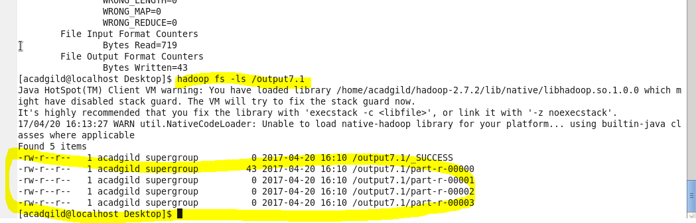

**OUTPUT**

